CSIT314 Software Development Methodologies - Group Project

Sprint 4 - US29: Search past IDPs
Interior Design Platform - Interior Designer
All diagrams were drawn in draw.io. Open "US29 Search past IDPs.drawio" in this folder to edit them - each diagram is its own page in that file. The exported images are in the "diagrams" folder.

Assumptions
- The system is the Interior Design Platform from the project specification. Sprint 4 covers the Interior Designer's past IDP stories (add, view, update, delete and search, US25 - US29) and the Customer's save IDP, search saved list and view saved list stories (US33 - US35).
- We follow B-C-E: the actor only talks to the boundary (page), the boundary only talks to the controller, and the controller works with the entity classes. There is one controller per use case.
- The boundary checks all the input (required fields, lengths, formats, e.g. not suspending your own profile) and trims spaces, then passes an entity object on. The controller just calls the entity and returns the result. The entity checks for duplicates and the database state (e.g. name already used, only Active rows are changed), then saves. In US29 the page trims the keyword and checks it is at most 100 characters (it can be empty); the controller just calls the entity, and the entity searches only the owner's Active past IDPs - it doesn't trim again.
- An IDP is an interior design project. A current IDP is one the designer is still working on (US20 - US24); a past IDP is a completed one (US25 - US29). Both are rows in the idp table with projectType Current or Past.
- Logged in as an interior designer (UC13) is the precondition. designerLoginRequired in app.py only sends someone with no session to /designer/login; the use case doesn't check the designer again (no InteriorDesignerLoginController).
- The keyword is matched (any case) against the title, the description, the location and the category name. Results are newest first, the same as US26.
- An empty (or only-spaces) keyword shows all of the designer's past IDPs; "Clear" goes back to the full list (US26). Current IDPs, deleted (Suspended) past IDPs and other designers' IDPs are never shown.
- No match is a normal page with "No past IDPs match your search" and the keyword kept in the box (also for an empty search when the designer has no past IDPs). A keyword longer than 100 characters gives "The keyword can be at most 100 characters" (HTTP 400) and the controller is not called.
- Searching is read-only. The search bar sits on the past IDPs list; "View" on a result opens the US26 details, where Update (US27) and Delete (US28) are.

1. User story
Story ID | US29
User story | As an interior designer, I want to search my past IDPs so that I can find the IDP I need to manage.
Actor | Interior Designer
Priority | Medium
Story points (estimate) | 2
Acceptance criteria | 1. Given I am on my past IDPs list, I can type a keyword in the search bar.  2. Given I type a keyword and click "Search", then I see my Active past IDPs whose title, description, location or category contains it (capitals don't matter), newest first, each with a "View" link, and my keyword stays in the box.  3. Given the keyword is empty, then I see all my past IDPs; "Clear" goes back to the full list.  4. Given nothing matches, then I see "No past IDPs match your search".  5. Given the keyword is longer than 100 characters, then I see "The keyword can be at most 100 characters" and nothing is searched.  6. Other designers' IDPs, current IDPs and deleted past IDPs never appear, and searching changes nothing.
Tasks | #191 Draw Use Case Diagram and Write Use Case Description  #199 Draw BCE and Sequence Class Diagram  #207 Implement a search function to find Past IDPs using relevant keywords.  #251 Design Wireframe  #258 Write and Execute Test Cases

2. Use case diagram
The user story becomes one use case, UC29 Search past IDPs. The Interior Designer is the only actor. Viewing a result continues in UC26.
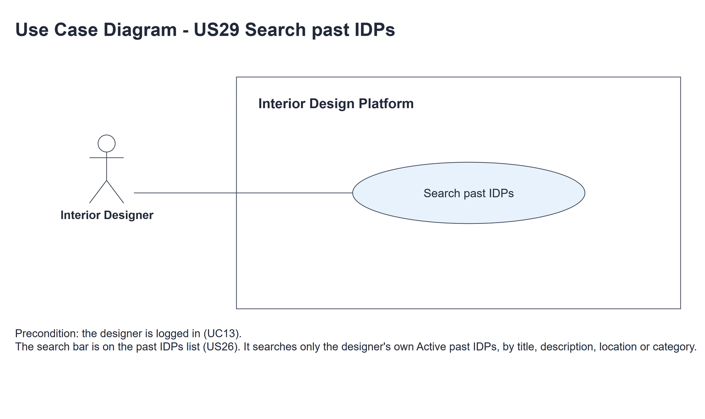
Figure 1: Use case diagram for US29 Search past IDPs

3. Use case description
Use case | UC29 Search past IDPs
Actor | Interior Designer
Brief description | The Interior Designer searches their own past IDPs to find the one they need to manage.
User story | US29: As an interior designer, I want to search my past IDPs so that I can find the IDP I need to manage.
Preconditions | The Interior Designer is logged in (UC13). designerLoginRequired in app.py only sends someone with no session to /designer/login.
Trigger | The Interior Designer types a keyword in the search bar on the past IDPs list and clicks "Search".
Basic flow | 1. The Interior Designer types a keyword and clicks "Search".  2. The system trims the keyword and checks it is at most 100 characters.  3. The system finds the designer's Active past IDPs whose title, description, location or category name contains the keyword, newest first.  4. The system shows the matching past IDPs with the keyword kept in the box.  5. The Interior Designer clicks "View" on a result and the details open (UC26).
Alternative flows | 1a. The keyword is empty: the system shows all of the designer's past IDPs.  2a. The keyword is longer than 100 characters: the system shows "The keyword can be at most 100 characters" (HTTP 400). Nothing is searched. Back to step 1.  3a. Nothing matches: the system shows "No past IDPs match your search" and keeps the keyword. Back to step 1.  5a. The IDP was deleted after the search: UC26 shows "Past IDP not found" (HTTP 404).
Postconditions | Nothing is changed. Another designer's IDPs are never shown.

4. Wireframes
The wireframes were drawn in draw.io. They are low-fidelity: they show the layout and the flow, not the final colours. The orange numbers match the notes under each screen.

4a - Search results
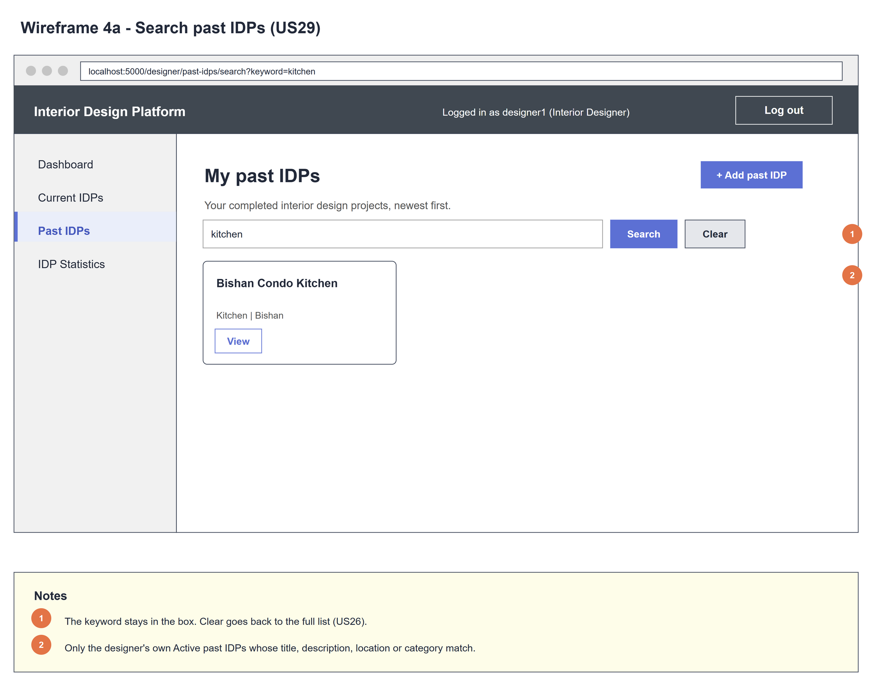
Figure 2: Wireframe 4a - Search results (US29)

4b - No matching results
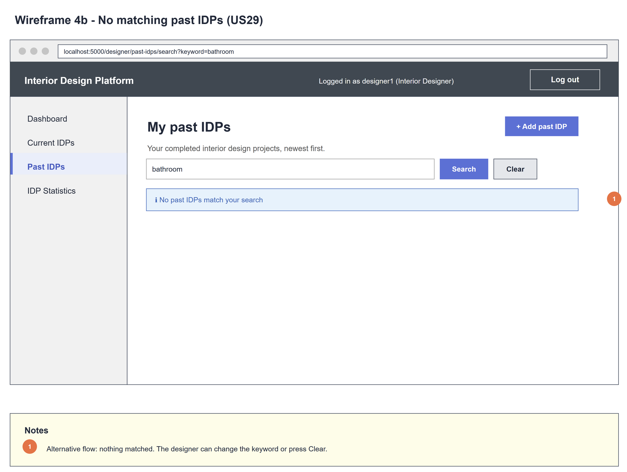
Figure 3: Wireframe 4b - No results (US29)

5. B-C-E class diagram
The solid line means the boundary calls the controller. The dashed line means the controller uses the entity. Only the operations needed for this use case are shown. categoryName is joined for display, it isn't a new column.
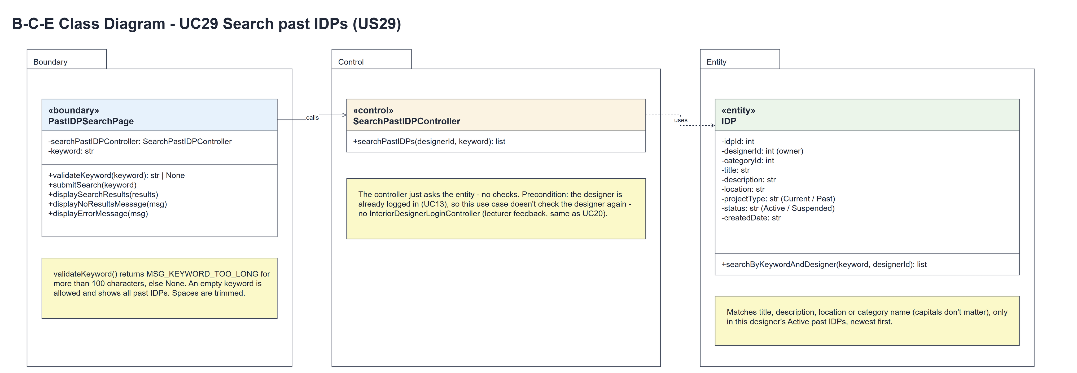
Figure 4: B-C-E class diagram for US29 Search past IDPs
Layer | Class | What it does
Boundary | PastIDPSearchPage | The search bar on the past IDPs list. submitSearch(keyword) trims the keyword and keeps it for the page; validateKeyword(keyword) returns MSG_KEYWORD_TOO_LONG for more than 100 characters (else None); then the page calls the controller with designerId = session userId and shows displaySearchResults(results), displayNoResultsMessage(MSG_NO_RESULTS) or displayErrorMessage(MSG_KEYWORD_TOO_LONG) (HTTP 400).
Control | SearchPastIDPController | Controller for UC29. searchPastIDPs(designerId, keyword) just calls IDP.searchByKeywordAndDesigner(keyword, designerId) and returns the result - no checks and no trimming.
Entity | IDP | The only entity. searchByKeywordAndDesigner(keyword, designerId) matches the keyword (any case) against the title, description, location and category name of the owner's Active past IDPs, newest first. An empty keyword returns all of them.

6. Sequence diagram
The sequence diagram follows UC29. The page trims the keyword and checks it with validateKeyword(keyword) (steps 1-2). The outer alt calls searchPastIDPs(designerId, keyword) when the keyword is valid, and the controller makes one call to IDP.searchByKeywordAndDesigner() (step 3). The inner alt shows the matching past IDPs (step 4) or the no-results message (3a). A keyword that is too long shows the error (HTTP 400) and the controller is never called (2a). Viewing a result is UC26.
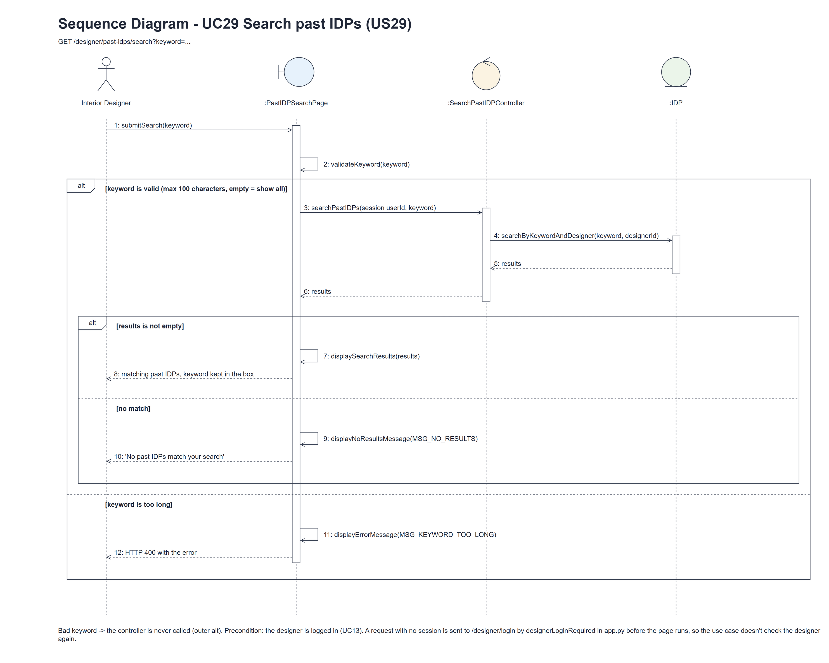
Figure 5: Sequence diagram for UC29 Search past IDPs

7. Test cases
Test data used below (the same as tests/test_us29_searchPastIDPs.py, which reuses the US25 helpers): designer accounts designer37 (A) and designer29b (B) / Design@123, made with UC8. IDP categories Kitchen and Bedroom (Active). A owns the past IDPs "Modern Kitchen" (Kitchen) and "Cosy Loft" (Bedroom), a deleted past IDP "My Deleted Kitchen" and a current IDP "My Current Kitchen"; B owns "Their Kitchen". Every test IDP has the description "Test project".

7a. System test cases (black box)
Equivalence partitioning and boundary value analysis were used to pick the test data. Fill in "Actual result" and "Pass/Fail" after running each test.
Test ID | Scenario | Prerequisites | Test steps | Test data | Expected result | Actual result | Pass / Fail
TC29.1 | Search by keyword | Logged in as A. | 1. Type the keyword / 2. Click "Search" | "Modern" | Modern Kitchen only; "Modern" stays in the box.
TC29.2 | Any capitals, category match | Logged in as A. | 1. Search | "BEDROOM" | Cosy Loft (its category is Bedroom).
TC29.3 | Description match | Logged in as A. | 1. Search | "test project" | Both of A's past IDPs, newest first.
TC29.4 | Empty keyword | Logged in as A. | 1. Search with an empty box | "" or only spaces | All of A's past IDPs.
TC29.5 | No match | Logged in as A. | 1. Search | "bathroom" | "No past IDPs match your search"; the keyword stays in the box.
TC29.6 | Keyword length (boundary) | Logged in as A. | 1. Search | 100 and 101 characters | 100: searched normally. 101: "The keyword can be at most 100 characters" (HTTP 400).
TC29.7 | Only own Active past IDPs | Logged in as A. | 1. Search | "kitchen" | Only Modern Kitchen - not My Deleted Kitchen, My Current Kitchen or Their Kitchen.
TC29.8 | Spaces are trimmed | Logged in as A. | 1. Search | " modern " | Modern Kitchen; the box shows "modern".
TC29.9 | Not logged in | Not logged in. | 1. Open /designer/past-idps/search?keyword=x | - | The designer login page is shown.

7b. Unit test cases (for TDD)
These are written before the code (test-driven development) and run with pytest (python -m pytest). They cover normal inputs, abnormal inputs and boundary values. Each one matches a test function in tests/test_us29_searchPastIDPs.py (UT29.1 is test_ut29_1_...). "Pass" is from the pytest run on 10 November 2026.
Test ID | Class and method | Input / setup | Expected output | Type | Pass / Fail
UT29.1 | IDP.searchByKeywordAndDesigner(keyword, designerId) | "MODERN"; "bedroom"; "test project" | [Modern Kitchen]; [Cosy Loft] (category); both | Normal | Pass
UT29.2 | IDP.searchByKeywordAndDesigner() | "kitchen" with A's deleted and current IDPs and B's IDP | Only A's Active past IDP | Abnormal | Pass
UT29.3 | IDP.searchByKeywordAndDesigner() | ""; "zzz" | All of A's past IDPs; [] | Boundary | Pass
UT29.4 | SearchPastIDPController.searchPastIDPs(designerId, keyword) | A, "modern" | [Modern Kitchen] - one entity call | Normal | Pass
UT29.5 | PastIDPSearchPage.validateKeyword(keyword) | "", 100 and 101 characters | None, None, MSG_KEYWORD_TOO_LONG | Boundary | Pass
UT29.6 | PastIDPSearchPage.submitSearch() | " modern " | Modern Kitchen shown, Rustic Kitchen not; the box shows "modern" (trimmed) | Normal | Pass
UT29.7 | PastIDPSearchPage.displayNoResultsMessage() | "zzz" | "No past IDPs match your search" | Abnormal | Pass
UT29.8 | PastIDPSearchPage.displayErrorMessage() | 101-character keyword | HTTP 400 with "The keyword can be at most 100 characters" | Boundary | Pass
UT29.9 | /designer/past-idps/search (designerLoginRequired) | Not logged in | Redirects to /designer/login | Abnormal | Pass
UT29.10 | IDP.searchByKeywordAndDesigner(keyword, designerId) | A also owns the past IDP "100% Recycled_Wood Kitchen"; keywords "%", "_" and "k%n" | [100% Recycled_Wood Kitchen] for "%" and for "_"; [] for "k%n" - % and _ are plain text, not wildcards | Abnormal | Pass

